Interfacing the Nucleo F429ZI Microcontroller to the DE-0 Cyclone IV FPGA using SPI

# Bill of Materials:

DE-0 Nano FPGA Board

Female-to-female ribbon connector (JP1)

STM32F429FZ Nucleo Board

Prototyping Wires (5 off)

# Software Required

Quartus Prime v16.1

Keil uVision 5.2x

PuTTY

# Document Revision

V1.0 - 01/12/2017 – Initial version for ELEC240

V1.01 – 01/12/2017 – Added a label to Figure 8 indicating the position of Pin 1

V1.02 – 14/11/2018 – Table of pin connections now on the same page as the figures to aid readability.

# Task 01-01 Connecting the FPGA to the Nucleo F429ZI Board

In this task, you will connect the FPGA to the Microcontroller, and run some demo code.

1. Connect the ribbon cable to the FPGA connector JP1 as shown in Figure 1

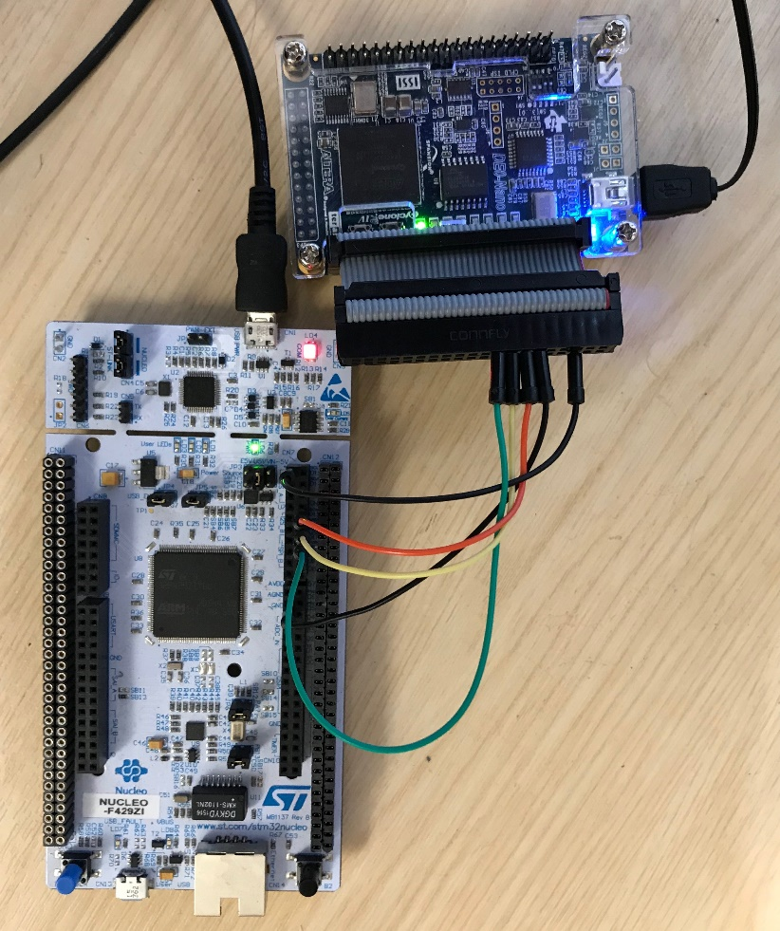

Figure 1. Showing the connections between the FPGA and the Nucleo Board

1. Using the connections in Table 1, connect the FPGA to the Nucleo Board using prototyping wires. Use Figure 4, Figure 5 and Figure 6 to locate the correct pins. Your connections should correspond with the close-up images in Figure 7 and Figure 8.
2. In Quartus, open the project in the FPGA folder. Build and deploy to the FPGA board
3. In Keil uVision, open the project inside the MCU Folder. Again, build and deploy to the Nucleo Board
4. Run device manager and note the COM port number used by that the “STMicroelectronics STLink Virtual COM Port” (see below)

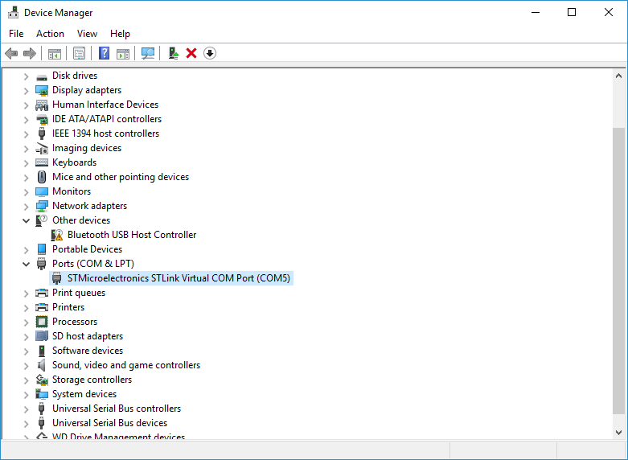

Figure 2. On Microsoft Windows, use the Device Manager to identify the COM port enumeration

You should now see the row of LEDs animate approximately once a second. You should also see the DE-0 Nano DIP switch positions reported in PuTTY. Carefully change the DIP switch settings using a pointed tool.

**Question**: Where and how in the MCU software do we read the switch positions?

**Question**: Briefly read the Wikipedia article on SPI. How is it possible we can read and write a value to a device at the same time?

# Task 01-02

This is a programming task to familiarize you with interfacing over SPI. Modify the C code to produce the following LED pattern:

All LEDs on

Wait for 1s

All LEDs off

Wait for 1s

All the even LEDs on

Wait for 1s

All the odd LEDs on

Wait for 1s

Repeat

# Task 01-03: Software Decoder

Modify the C code to use three DIP switches to **select** which LED is on. Choose three DIP switches to represent a 3-bit binary select value.

Your main loop should read back the DIP switch settings from the FPGA (unsigned integer), and send a command to light the corresponding LED. Note that SPI reads and writes a byte at the same time.

**For example:**

SW3, SW2 and SW1 set to 111 all on would result in LED7 being illuminated (sends binary 10000000)

SW3, SW2 and SW1 set to 000 all on would result in LED0 being illuminated (sends binary 00000001)

SW3, SW2 and SW1 set to 010 all on would result in LED2 being illuminated (sends binary 00000100)

In effect, you are building a **software decoder**.

# Task 01-04: Hardware Decoder

Currently we are sending 8-bits of data over the SPI interface, and this allows us to specify any of the $2^{8}$ combinations of 8-LEDs we choose. However, where we only require a subset of N combinations, then we only need $\left\lceil \log_{2}\left(N\right)\right\rceil$ bits (where $\left\lceil x\right\rceil$ is the mathematical operator for rounding to the higher integer).

Design some logic in VHDL to perform hardware decoding. The MCU shall send data over SPI using the following format. The bits S2 down to S0 make up a 3-bit value, which determines which LED should be lit (000 for LED0, 111 for LED7 etc..).

|  |  |  |  |  |  |  |  |
| --- | --- | --- | --- | --- | --- | --- | --- |
| msb |  |  |  |  |  |  | Lab |
| S2 | S1 | S0 | Not used | Not used | Not used | Not used | Not used |

Write some C code to generate some values to test your design – show the tutor when you’ve done this.

Note that we only have 8 different LED combinations, so we only need $\log_{2}8=3$ bits to specify. The remaining bits could be used for other purposes.

# Task 01-04 Progressive Display

This is similar to task 01-04, only the logic will display a progressive display instead of a single LED. You will need to modify your VHDL to achieve this. There are still only 8 unique patterns, so again, we only need 3 bits to set the output state.

|  |  |  |  |  |  |  |  |  |  |  |
| --- | --- | --- | --- | --- | --- | --- | --- | --- | --- | --- |
| S2 | S1 | S0 | LED7 | LED6 | LED5 | LED4 | LED3 | LED2 | LED1 | LED0 |
| 0 | 0 | 0 | 0 | 0 | 0 | 0 | 0 | 0 | 0 | 1 |
| 0 | 0 | 1 | 0 | 0 | 0 | 0 | 0 | 0 | 1 | 1 |
| 0 | 1 | 0 | 0 | 0 | 0 | 0 | 0 | 1 | 1 | 1 |
| 0 | 1 | 1 | 0 | 0 | 0 | 0 | 1 | 1 | 1 | 1 |
| 1 | 0 | 0 | 0 | 0 | 0 | 1 | 1 | 1 | 1 | 1 |
| 1 | 0 | 1 | 0 | 0 | 1 | 1 | 1 | 1 | 1 | 1 |
| 1 | 1 | 0 | 0 | 1 | 1 | 1 | 1 | 1 | 1 | 1 |
| 1 | 1 | 1 | 1 | 1 | 1 | 1 | 1 | 1 | 1 | 1 |

**Question**. How might you compare the “output logic” of a Moore machine to a decoder? Might you classify this logic as a decoder?

# Task 02 – Debugging Hardware with Signal Tap

In this task we are going to perform some on-chip FPGA hardware debugging. Quartus has a facility to add some additional logic to your design. This logic acts as a **logic analyser**. It samples internal signals, and uses on-chip[1] RAM to store them until the RAM is full. It then sends them back to Quartus (over USB) for display in a timing diagram.

* Open the Quartus project file in Task02/FPGA. Build and program.
* Open the Keil uVision project file in Task02/MCU. Build and deploy.

This should produce the simple knight-rider[2] LED pattern. We are now going to capture some of the SPI data in real-time and observe this in Quartus.

**TASK**

In the project navigator, panel switch to the Files view. Then double click top open the stp1.stp file (stp is short for Signal TaP). A window similar to that in Figure 3 should appear.

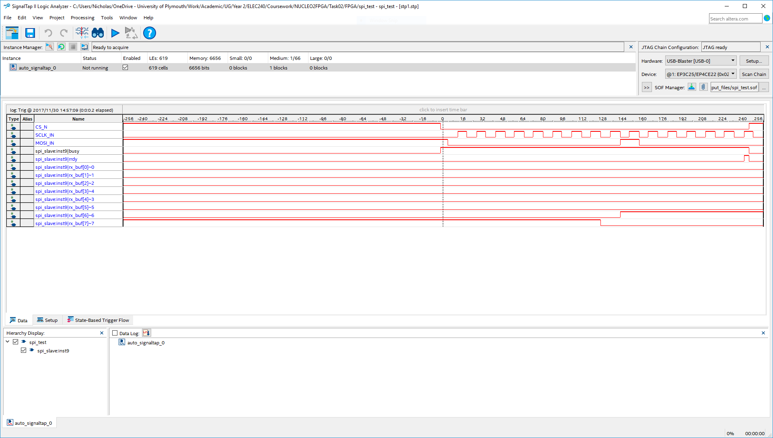

3

2

1

Figure 3. Showing the Signal Tap interface

1. Click the build button (1) to build your design + the signal tap logic analyser block. Wait for the build to complete
2. Click the program button (2) to deploy the design
3. Click the capture button (3) or press F5 to capture the data. You should see a timing diagram similar to that in Figure 3 appear. If can press F5 again, you will probably capture a different data value.

You can cross reference the signals shown with the following article <https://eewiki.net/pages/viewpage.action?pageId=7569477>

**Questions / research tasks:**

Which device is the Master and which is the Slave?

What do MISO and MOSI mean?

Which bit is sent first by the master?

Which bit is received first by the slave?

What is the purpose of the chip select (CS)?

# Appendix A – Nucleo and DE0-Nano Connections

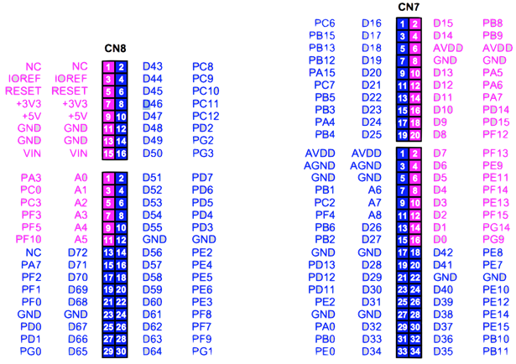

Figure 4 Nucleo Pinouts

|  |  |  |  |
| --- | --- | --- | --- |
| Signal | MCU Pin (CN7) | FPGA Pin (JP1) |  |
| CS | PC_6 (D16) – Pin1 | A2 (JP1-Pin 5) GPIO_2 |
| GND | GND - Pin8/Pin22 | Pin12 |
| SCLK | PA_5 (D13) - pin10 | D5 (JP1-Pin14) GPIO_9 |
| MISO | PA_6 (D12) - pin12 | A6 (JP1-Pin16) GPIO_11 |
| MOSI | PA_7 (D11) – pin14 | D6 (JP1-Pin18) GPIO_13 |
| Table 1. Pin Assignments.  Note that only connector CN7 is used on the Nucleo Board and JP1 on the DE0-Nano FPGA board. Pin 8 on CN7 is strictly analogue ground, however this is connected to digital ground on this board. Note also that the pin number of the FPGA = pin number of the MCU + 4, making it easy to construct a ribbon cable. | | |
| Figure 5. DE0-Nano Pinouts for JP1 |

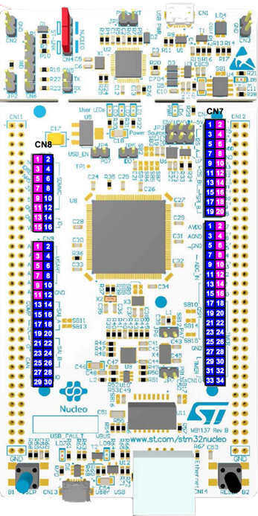

Figure 6. Nucleo FZ429ZI

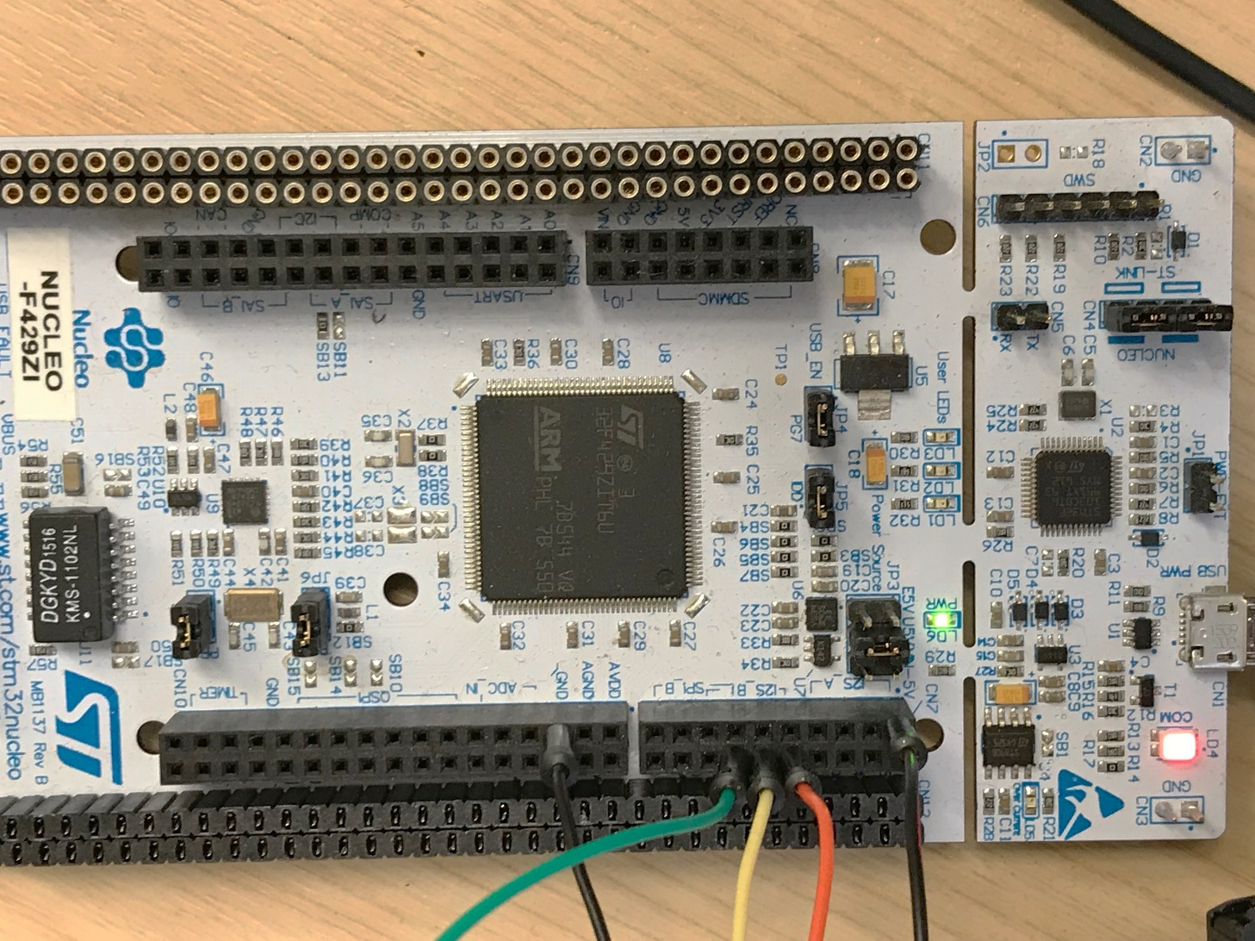

Figure 7. Showing the connections on the Nucleo board CN7 connector.

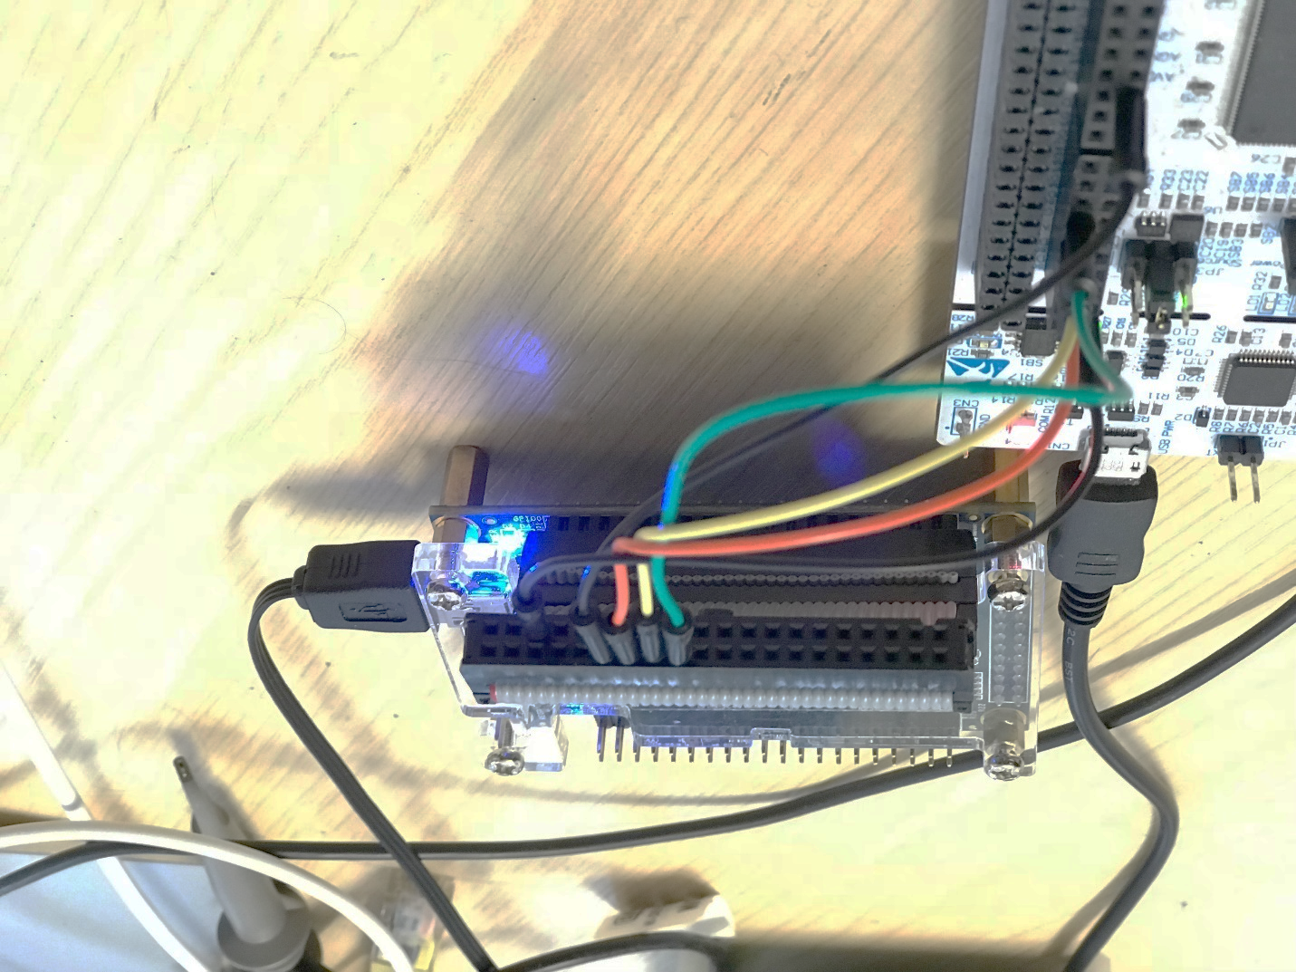

Pin 1

Figure 8. Showing the connection to the FPGA DE-0 Nano Board

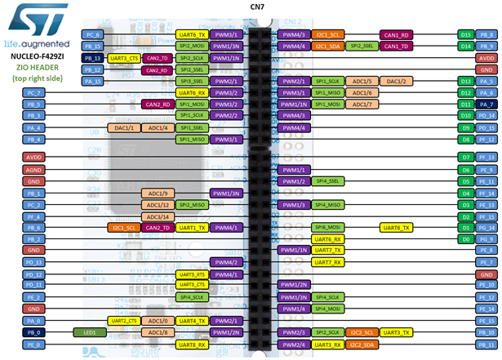

Figure 9. Showing the alternative functions of the pins on the Nucleo F429ZI CN7 connector

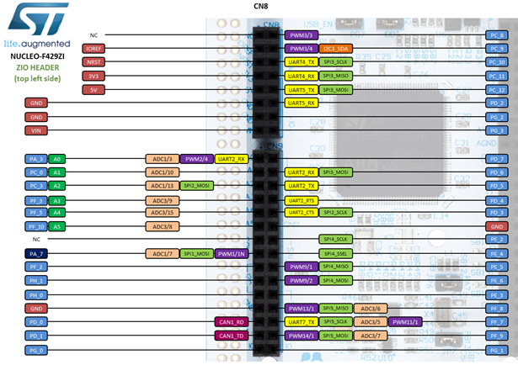

1. FPGA
2. <https://www.youtube.com/watch?v=Mo8Qls0HnWo>